# **Proposed level of Achievement:** Apollo 11

# Motivation

As busy students with many tasks and activities throughout the semester, it is difficult and boring to keep track of the numerous assignments and deadlines that we have. It is also hard to stay focused and meet these deadlines as we get easily distracted by our phones while studying.

If only there was an all inclusive application that could help us remember important dates and at the same time, help us to focus when we need to, while helping us to relax and enjoy during our breaks.

# Aim

To have adorable interactive virtual pets that will remind you of your deadlines and help you to stay focused while studying.

# Features of prototype

## Home Page

Buttons to access the various features of the application.

## Coin system

We have made a coin system that would save the amount of coins on the user’s phone. This would ensure that when the user visits other pages in the application or closes the application, the number of coins would not be lost. The update coins function will be called whenever there is a change in number of coins or when the application closes.

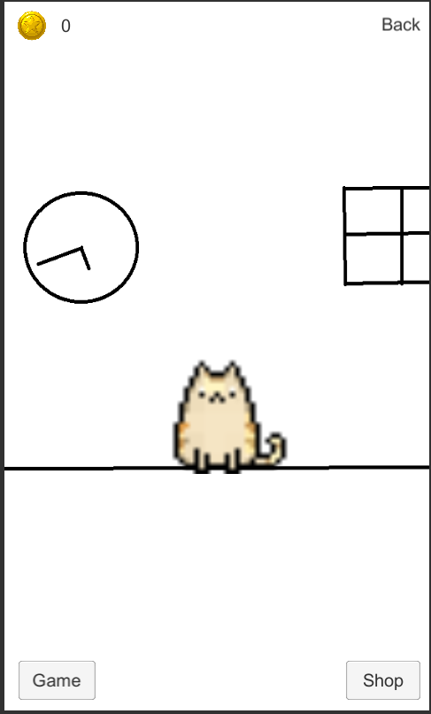

## Pets

This is the pet page of the application. Here you would see your selected pet and be able to pet it once a day for 1 coin. Attempting to pet it more than once per day would result in nothing happening. On the bottom left corner will be the button to enter different mini-games (not implemented yet) while on the bottom right will be the button to enter the shop. Sadly, the clock on the wall is purely aesthetic (I drew it) but we intend to make it working. (and also come up with a nicer background)

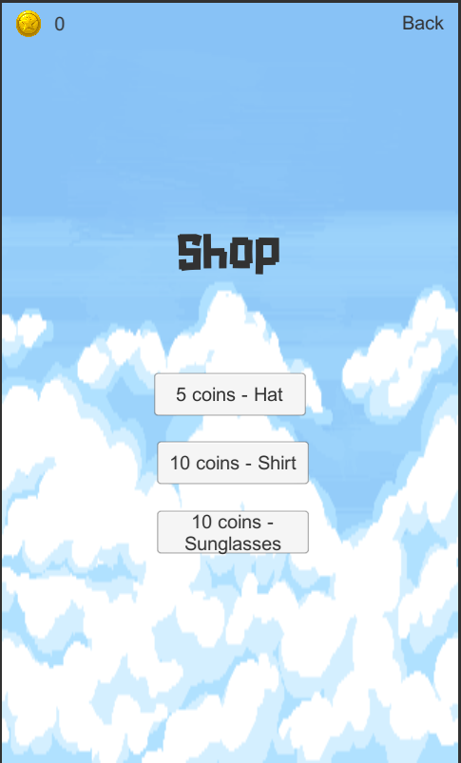

## Shop page

This will be a rough guideline of what the shop page will look like. As of milestone 2, we have not implemented the cosmetics and inventory system, this page is mainly used to ensure that the coin system is working and make sure that the coin values will not hit negative.

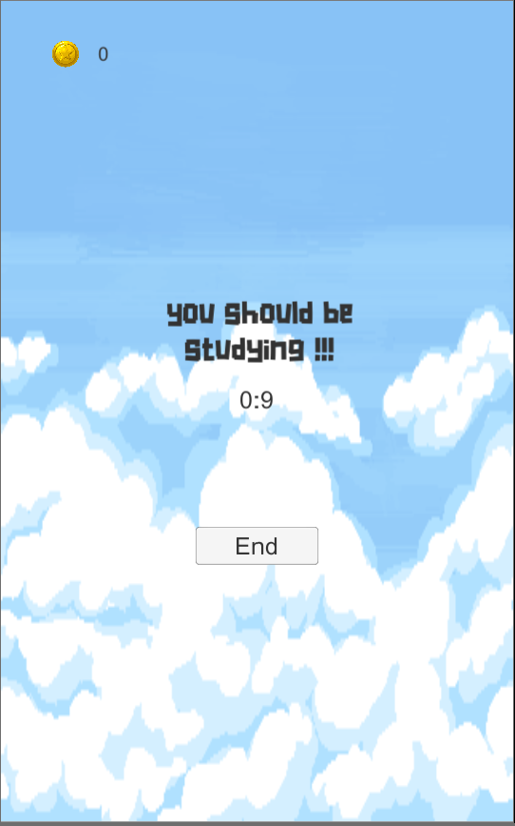

## Study Mode

This is one of the main features of our application. When the user clicks study mode from the home page, they will come to this page and the timer will automatically start. To end study mode, users must click the button End or simply just close or minimize the application. This achieves the purpose as study mode aims to prevent the user from being distracted by his phone while studying. When the end button is pressed, the text on the screen changes and depending on the amount of time spent in study mode, different text appears. Coins are also awarded based on the amount of time in study mode, every 15mins would result in a coin.

## Battery saving

Another feature of study mode is battery saving. As users study and leave study mode on their phone, we want their phones to be able to last the distance. Thus we implemented a frame rate cap of 10fps, down from the normal 60fps. By milestone 3, we want to also include a brightness dimming feature to further bring down battery usage while in study mode.

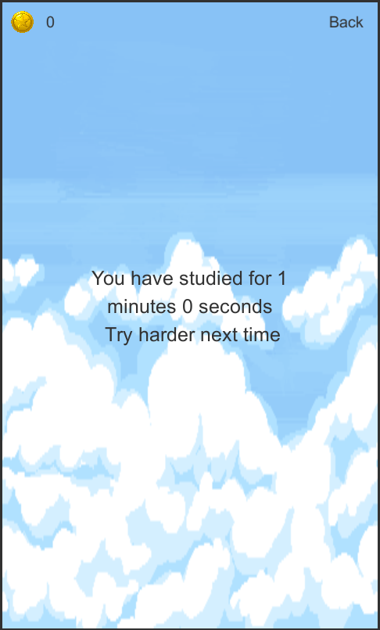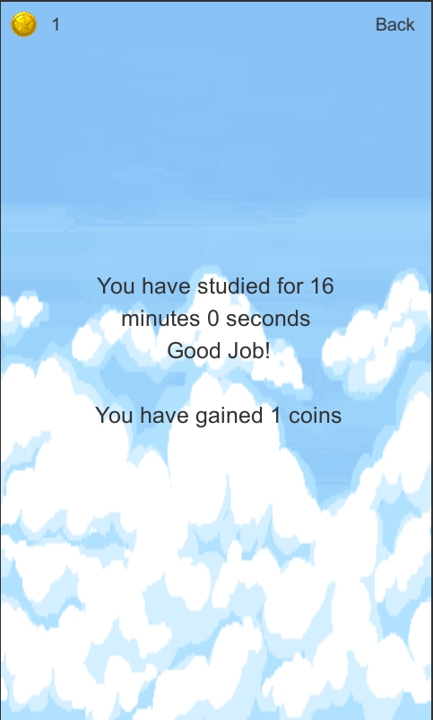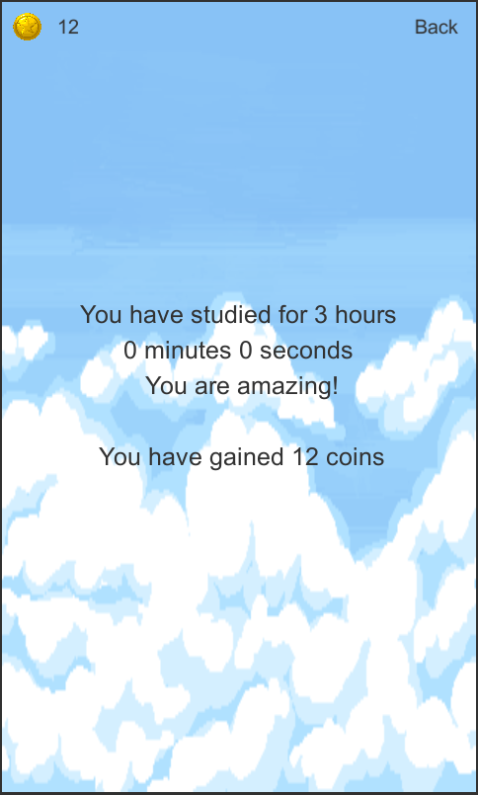

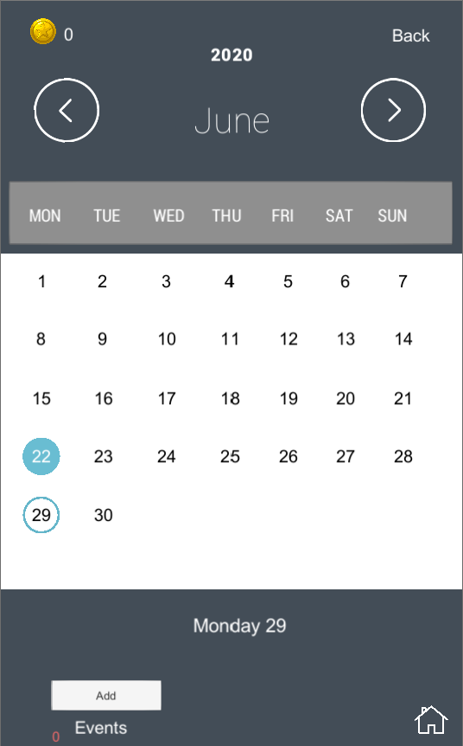

## Calendar

The next main feature of our app is the calendar function. We have successfully implemented an auto generating calendar (thus being infinite) which allows users to select days and add events using the add event button at the bottom. This would prompt an input game object to appear as shown in the next image

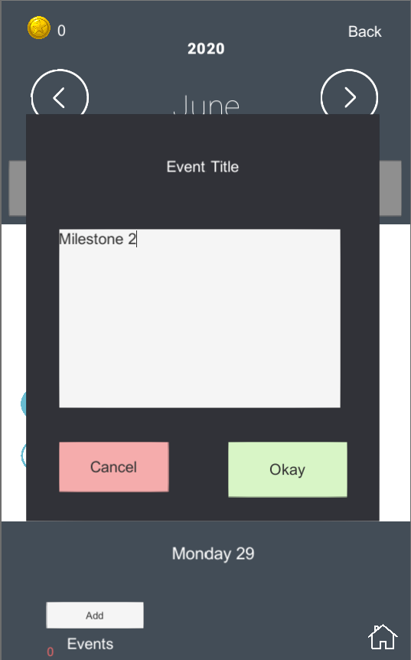

## Add Event

Here is the display of the add event button. As of now, events are only stored by day. By milestone 3, we aim to be able to set events to a more specific time, and also implement push notifications to allow the application to notify the user when these events occur. By noting down events such as deadlines and exams in our application, users would receive 5 coins per event.

# Features that will be in the final product

* A registration page for the user to key in his name and select his first pet
  + We want the application to send custom messages with the user’s name as a way to make it more personalized.
* Multiple pets for the player to choose
  + We aim to have a variety of pets that the user can choose from when they first start using the application
* Nicer backgrounds
  + Nothing much to be said here
* Inventory system for the pets to store cosmetic items
  + One of the main features of our application is the coin system. But what’s the point of a coin system if you have nothing to spend on? One of the main goals for the next milestone would be to have a cosmetic/inventory system that the user can spend coins on. This would cause users to want to earn coins more and thus, use the application.
* Achievements
  + We plan to add achievements into the application, some examples of achievements would be, “Spend 50 hours in study mode” or “Complete 10 events”. These achievements would unlock special cosmetic items or simply give coins to the user.
* Mini Games to play with your pet
  + A feature we want to implement would be mini games with the pet. So far, we have tried implementing a pong game that uses the pet as the ball, however we faced some difficulty and thus would not be part of this milestone. However by the next milestone, we aim to have at least 3 different minigames available to be played.
* Online friend system
  + This would be the final feature of our application, allowing users to be connected to the internet and add friends. They would also be able to see who is online and who is in study mode. We feel that this would be very beneficial as friends would be motivated by seeing their friends studying.

